AWS IAM Cloud Security Project

# 1. Project Overview

I completed this project on cloud security controls in Amazon Web Services (AWS), focusing on Identity and Access Management (IAM). The goal was to create a least‑privilege policy, attach it to a user group, and verify that the policy correctly restricts actions on two Amazon EC2 instances (audit and sales).

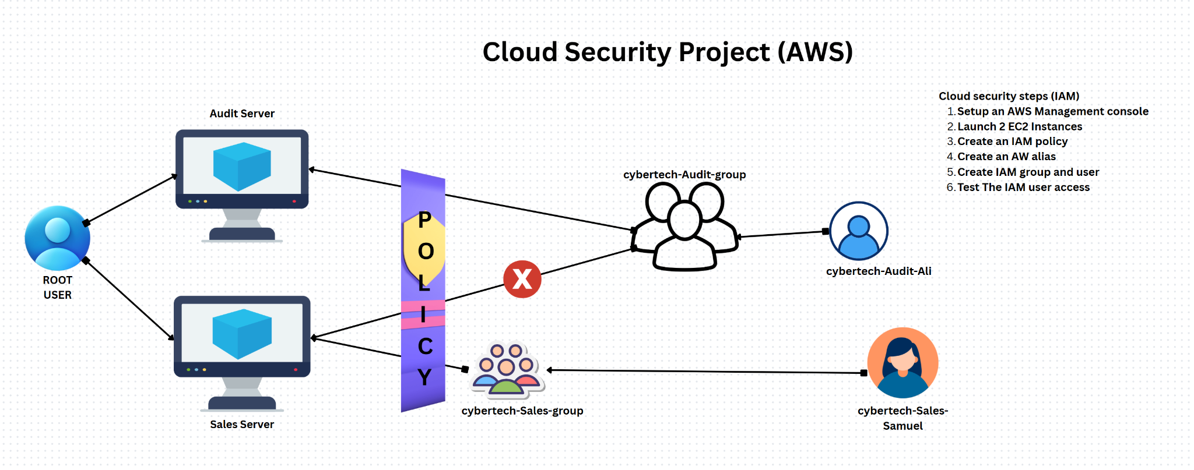

# 2. Tools & Concepts

* AWS IAM – users, groups, policies, account alias
* Amazon EC2 – instance tagging and lifecycle actions
* JSON policy syntax – Effect, Action, Resource
* Principle of least privilege and policy testing

# 3. Tagging Strategy

I applied a descriptive tag to each EC2 instance:  
Instance | Tag Key | Tag Value  
audit | Environment | Audit  
sales | Environment | Sales

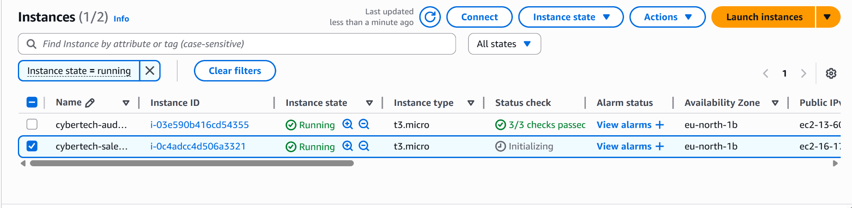

# 4. Creating the IAM Policy

I authored the following JSON policy to block instance stop/start actions on the audit server but allow those actions on the sales server:

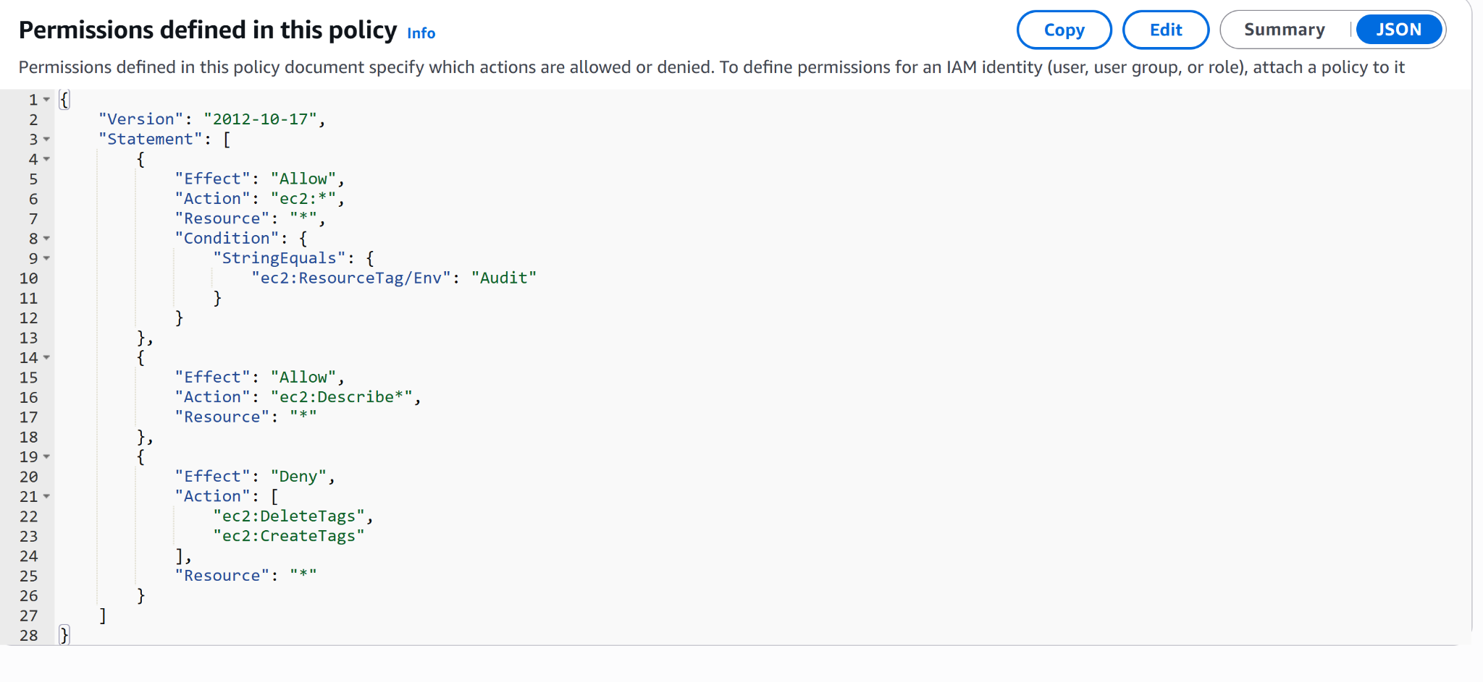

# 5. Account Alias

I set a memorable account alias to replace the default numeric URL, making sign‑in easier for team members.

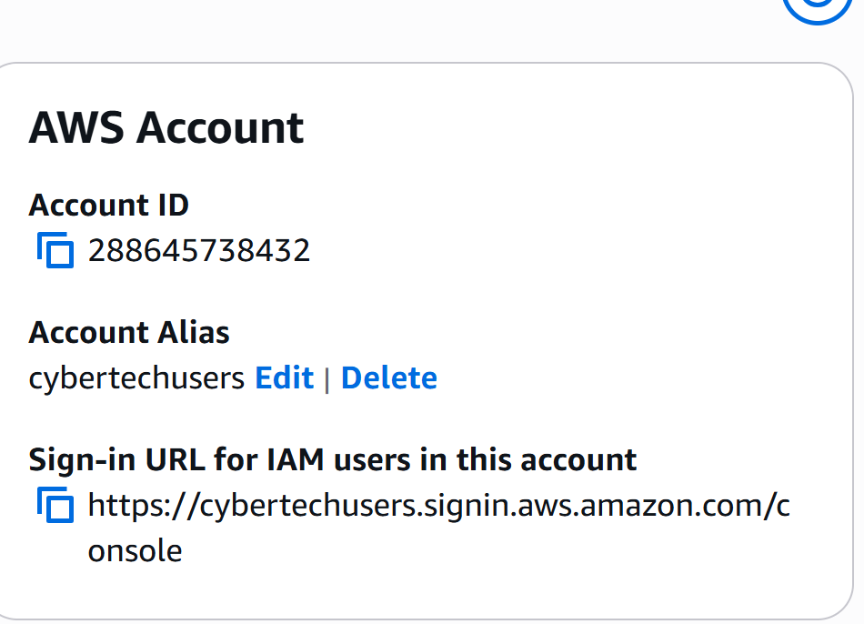

# 6. IAM Users & Groups

1. Created an IAM user group called Developers.  
2. Attached the **CybertechAuditEnvPolicy** policy to the group.  
3. Added individual IAM users who require controlled EC2 access.

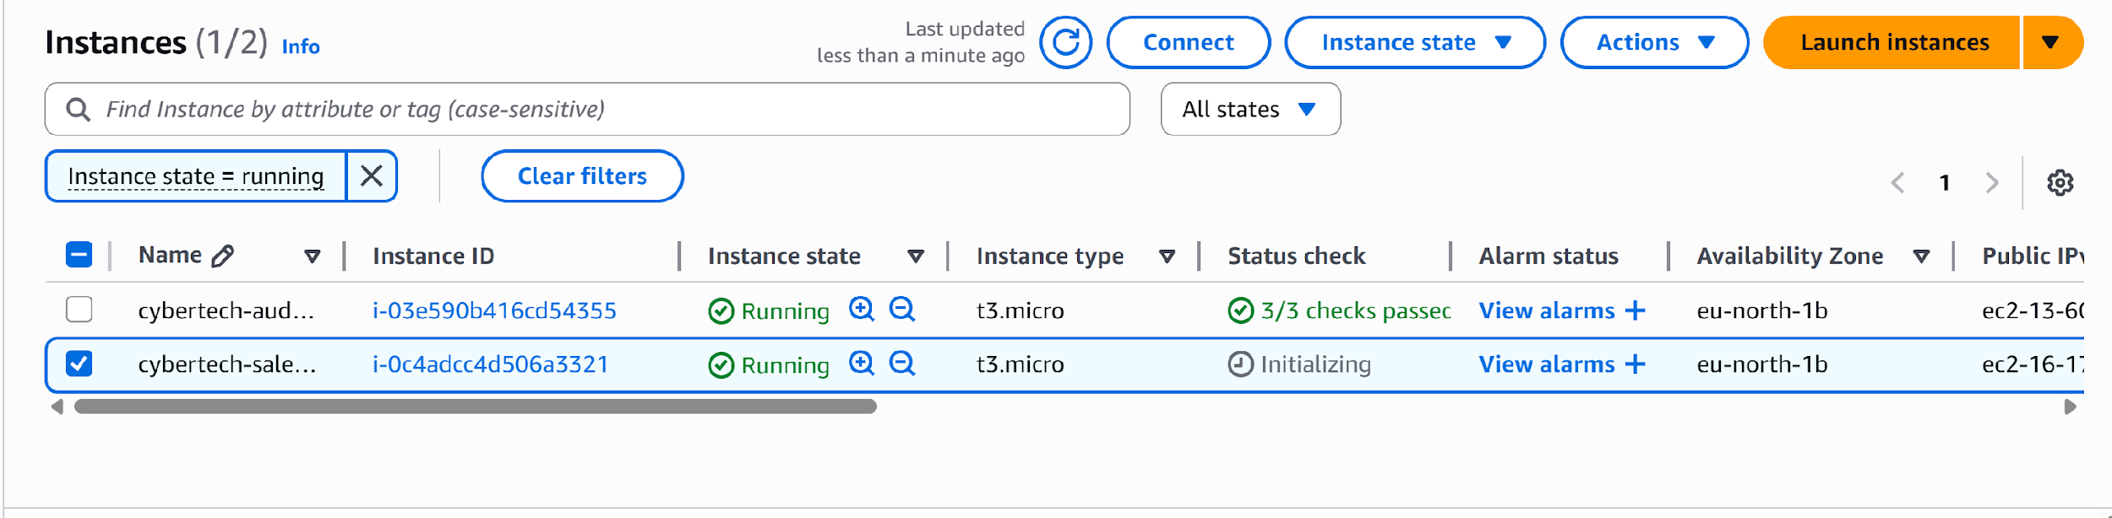

# 7. Logging in as an IAM User

IAM users can sign in through:  
- AWS Management Console (using the new alias URL)  
- AWS CLI via programmatic keys

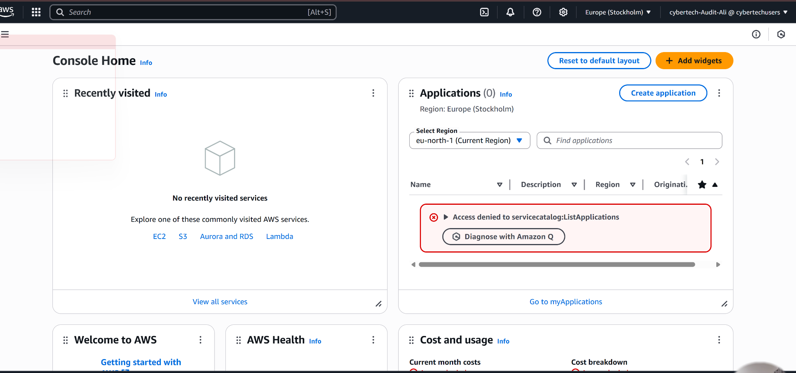

# 8. Testing the Policy

Test Action | Expected Result | Actual Result  
Stop audit instance | Denied | Access denied error displayed  
Stop sales instance | Allowed | Instance stopped successfully  
Start audit instance | Denied | Access denied error displayed  
Start sales instance | Allowed | Instance started successfully

